Computer Networks Lab

## Student Name: Hamza Farooq

## Registration: 2016-CS-122

## Question 1

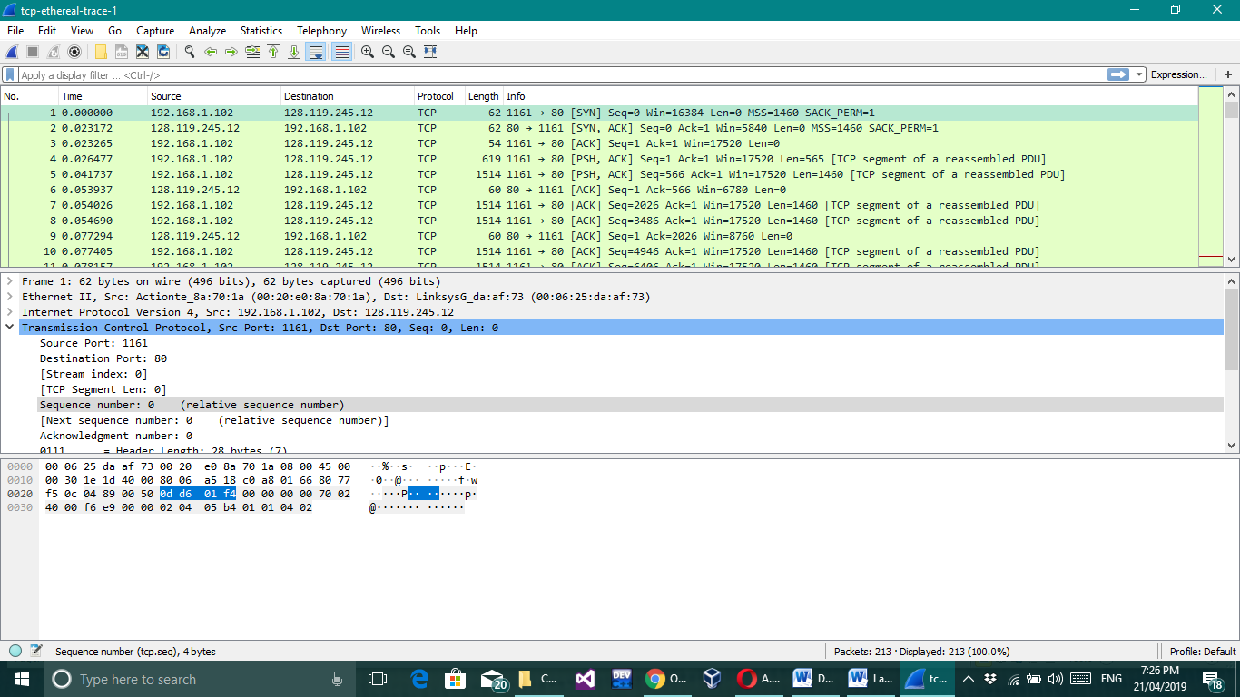What is the sequence number of the TCP SYN segment that is used to initiate the TCP connection between the client computer and gaia.cs.umass.edu? What is it in the segment that identifies the segment as a SYN segment?

## Question 2

What is the sequence number of the SYNACK segment sent by gaia.cs.umass.edu to the client computer in reply to the SYN? What is the value of the Acknowledgement field in the SYNACK segment? How did gaia.cs.umass.edu determine that value? What is it in the segment that identifies the segment as a SYNACK segment?

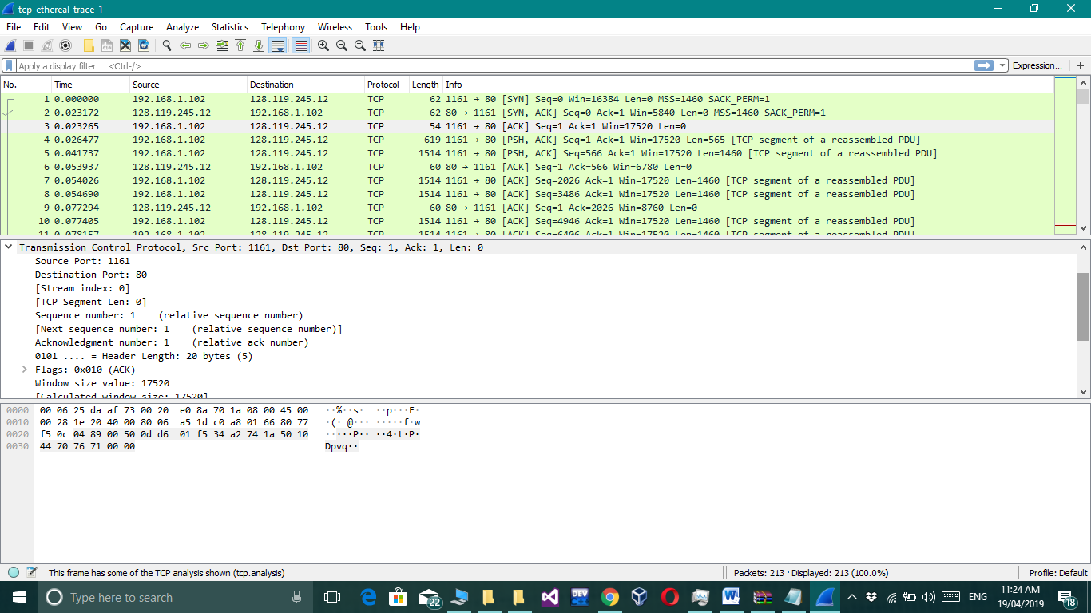

## Question 3

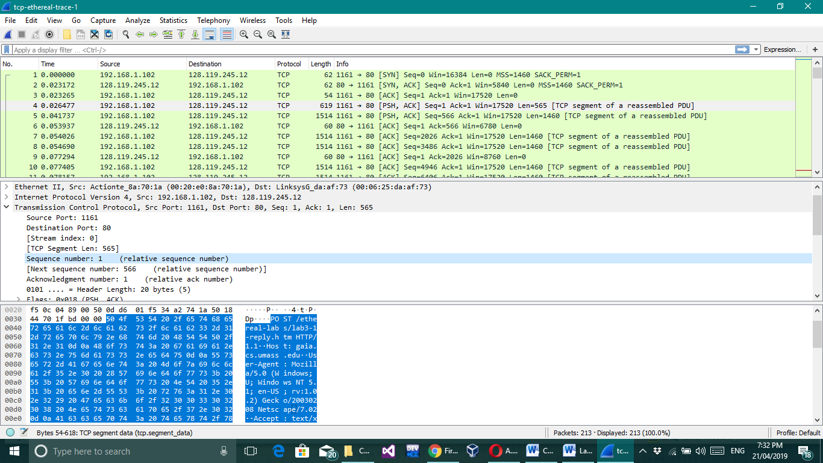What is the sequence number of the TCP segment containing the HTTP POST command? Note that in order to find the POST command, you’ll need to dig into the packet content field at the bottom of the Wireshark window, looking for a segment with a “POST” within its DATA field.

## Question 4

Consider the TCP segment containing the HTTP POST as the first segment in the TCP connection. What are the sequence numbers of the first six segments in the TCP connection (including the segment containing the HTTP POST)? At what time was each segment sent? When was the ACK for each segment received? Given the difference between when each TCP segment was sent, and when its acknowledgement was received, what is the RTT value for each of the six segments? What is the Estimated RTT value (see Section 3.5.3, page 239 in text) after the receipt of each ACK? Assume that the value of the Estimated RTT is equal to the measured RTT for the first segment, and then is computed using the Estimated RTT equation on page 239 for all subsequent segments.

|  |  |  |  |  |  |
| --- | --- | --- | --- | --- | --- |
| Segment # | Sequence # | Sent Time | Received Sq # | Received Time | Estimated Round Trip Time |
| 1 | 1 | 0.026477 | 1 | 0.053937 | 0.02746 |
| 2 | 566 | 0.041737 | 1 | 0.077294 | 0.031542 |
| 3 | 2026 | 0.54026 | 1 | 0.124085 | 0.04358 |
| 4 | 3486 | 0.054690 | 1 | 0.169118 | 0.06451 |
| 5 | 4946 | 0.077405 | 1 | 0.217299 | 0.08819 |
| 6 | 6406 | 0.07815 | 1 | 0.267802 | 0.120168 |

## Question 5

What is the sequence number of the SYNACK segment sent by gaia.cs.umass.edu to the client computer in reply to the SYN? What is the value of the Acknowledgement field in the SYNACK segment? How did gaia.cs.umass.edu determine that value? What is it in the segment that identifies the segment as a SYNACK segment?

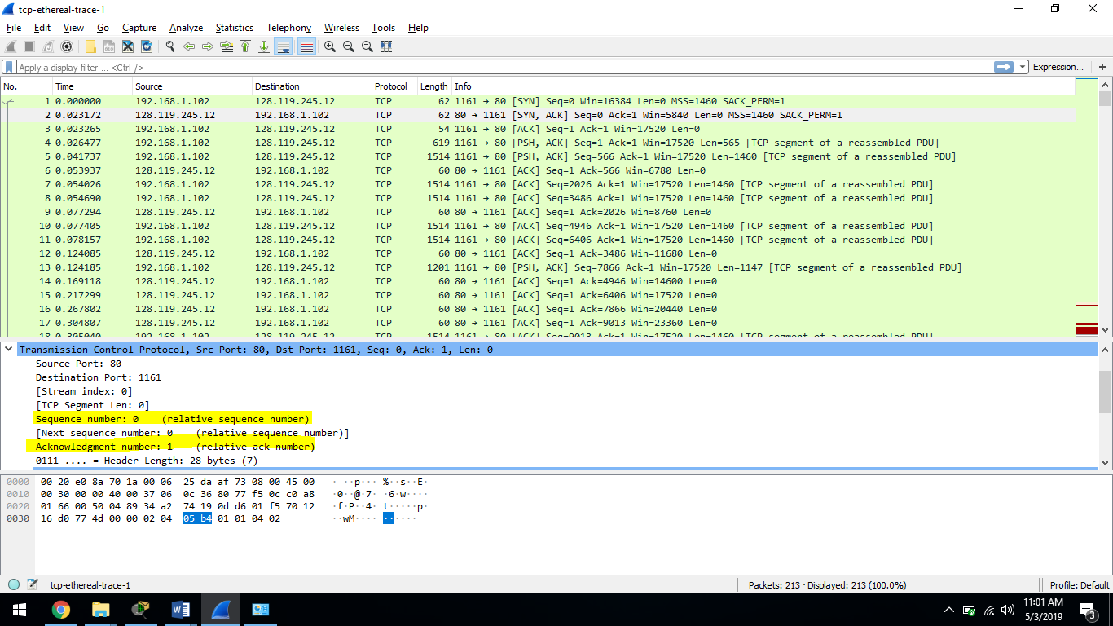

## Question 6

What is the sequence number of the TCP segment containing the HTTP POST command? Note that in order to find the POST command, you’ll need to dig into the packet content field at the bottom of the Wireshark window, looking for a segment with a “POST” within its DATA field.

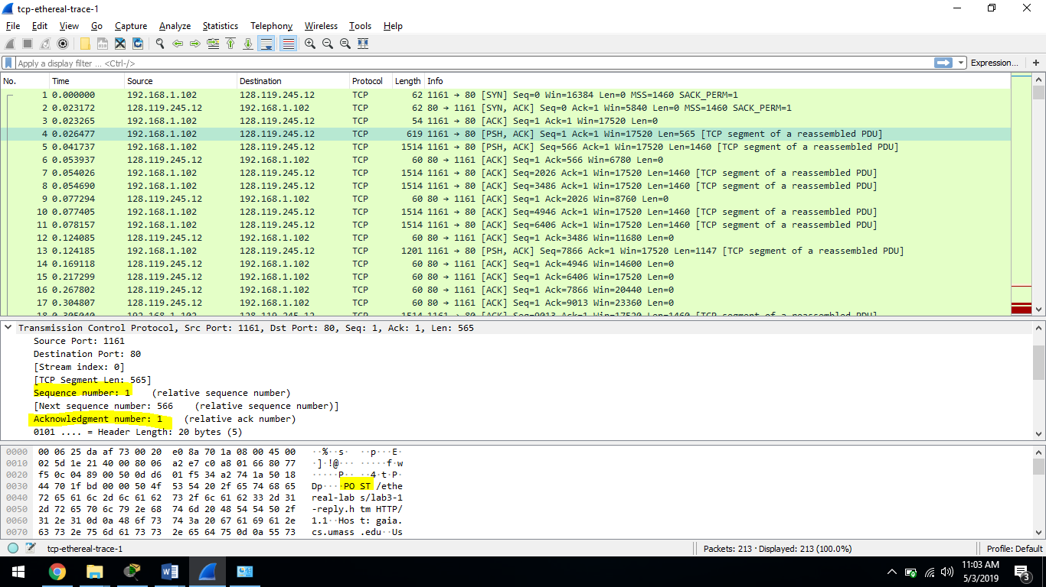

## Question 7

Consider the TCP segment containing the HTTP POST as the first segment in the TCP connection. What are the sequence numbers of the first six segments in the TCP connection (including the segment containing the HTTP POST)? At what time was each segment sent? When was the ACK for each segment received? Given the difference between when each TCP segment was sent, and when its acknowledgement was received, what is the RTT value for each of the six segments? What is the EstimatedRTT value (see Section 3.5.3, page 239 in text) after the receipt of each ACK? Assume that the value of the EstimatedRTT is equal to the measured RTT for the first segment, and then is computed using the EstimatedRTT equation on page 239 for all subsequent segments.

*Note:* Wireshark has a nice feature that allows you to plot the RTT for each of the TCP segments sent. Select a TCP segment in the “listing of captured packets” window that is being sent from the client to the gaia.cs.umass.edu server. Then select: *Statistics->TCP Stream Graph->Round Trip Time Graph.*

1) Seq = 1 sent at 0.001504; ACK received at 0.001616

2) Seq = 579 sent at 0.001776; ACK received at 0.002102

3) Seq = 3499 sent at 0.002119; ACK received at 0.002315

4) Seq = 9399 sent at 0.002332; ACK received at 0.002621

5) Seq = 21019 sent at 0.002648; ACK received at 0.002906

6) Seq = 44379 sent at 0.002927; ACK received at 0.003310

According to the formula: Estimated RTT = 0.875 * EstimatedRTT + 0.125 * SampleRTT

**EstimatedRTT of segment 4**:

EstimatedRTT = RTT for Segment 4 = 0.02746 s

**EstimatedRTT of segment 5**:

EstimatedRTT = 0.875 * 0.02746 + 0.125 * 0.035557 = 0.028472 s

**EstimatedRTT of segment 7**:

EstimatedRTT = 0.875 * 0.028472 + 0.125 * 0.070059 = 0.03367 s

**EstimatedRTT of segment 8**:

EstimatedRTT = 0.875 * 0.03367 + 0.125 * 0.114428 = 0.0437655 s

**EstimatedRTT of segment 10**:

EstimatedRTT = 0.875 * 0.0437655 + 0.125 * 0.139894 = 0.055782 s

**EstimatedRTT of segment 11**:

EstimatedRTT = 0.875 * 0.055782 + 0.125 * 0.189645 = 0.072515 s

## Question 8

What is the length of each of the first six TCP segments?[1]

Length of each of the six TCP segments is 565, 1460, 1460, 1460, 1460 and 1460 respectively.

## Question 9

What is the minimum amount of available buffer space advertised at the received for the entire trace? Does the lack of receiver buffer space ever throttle the sender?

The minimum amount of available buffer space advertised at the received for the entire trace is indicated first ACK from the server, its value is 5740 bytes.

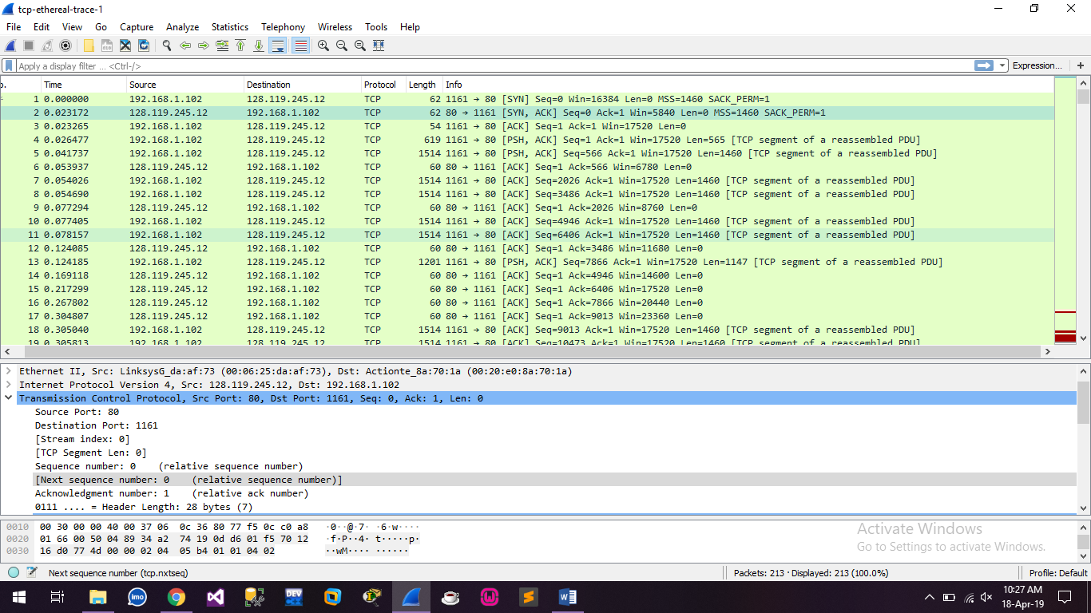

## Question 10

Are there any retransmitted segments in the trace file? What did you check for (in the trace) in order to answer this question?

There is no retransmitted segments in the trace file since in the time sequence graph, all sequence numbers are increasing.

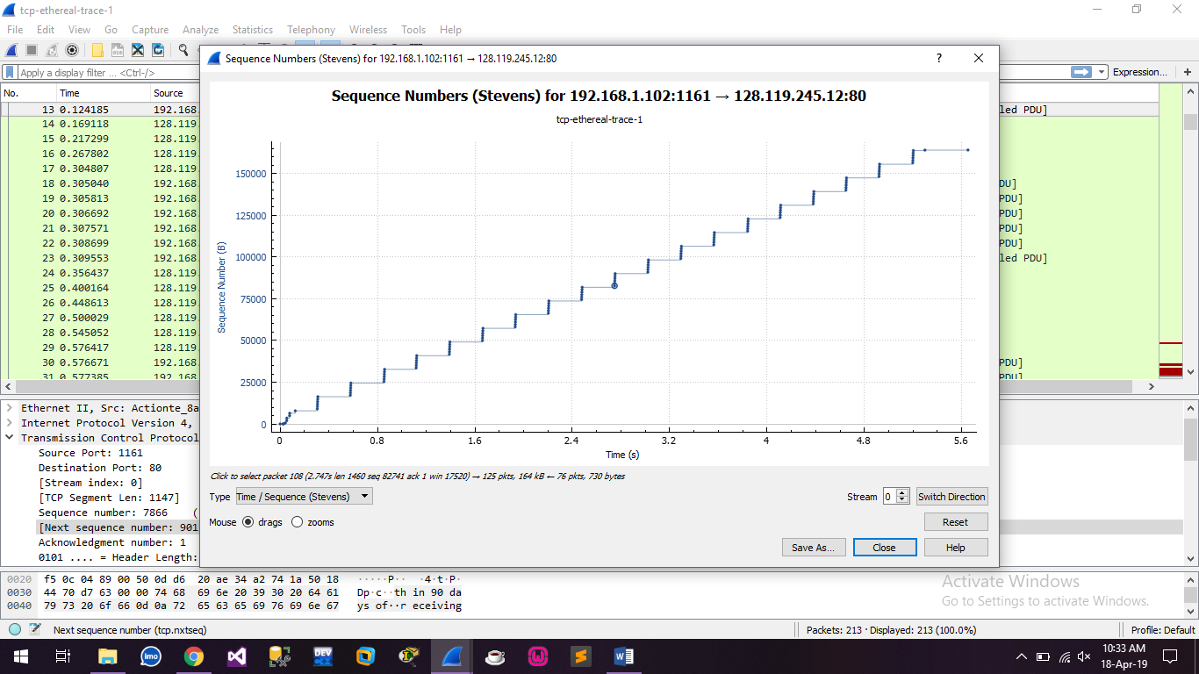

## Question 11

How much data does the receiver typically acknowledge in an ACK? Can you identify cases where the receiver is ACKing every other received segment (see Table 3.2 on page 247 in the text).

The difference between the acknowledged sequence numbers of two consecutive ACKs indicates the data received by the server between these two ACKs.

The receiver is ACKing every other segment. For example, segment of No. 9 has sequence number 4946 and 10 as 6406.So, acknowledged data is 1460 bytes.

## Question 12

What is the throughput (bytes transferred per unit time) for the TCP connection? Explain how you calculated this value.

I looked to the FINACK packet which shows a acknowledgement number of 152900, meaning

that 152900 bytes were acknowledged (this is consistent with the length of the alice.txt _le).

The time on this message is 0.007525. So an approximate average throughput can be calculated

as 152900 bytes

0:007525 seconds _ 2:032 MBps (mega bytes per second) for this connection. See screenshot

below.

## Question 13

Use the *Time-Sequence-Graph(Stevens*) plotting tool to view the sequence number versus time plot of segments being sent from the client to the gaia.cs.umass.edu server. Can you identify where TCP’s slowstart phase begins and ends, and where congestion avoidance takes over? Comment on ways in which the measured data differs from the idealized behavior of TCP that we’ve studied in the text.

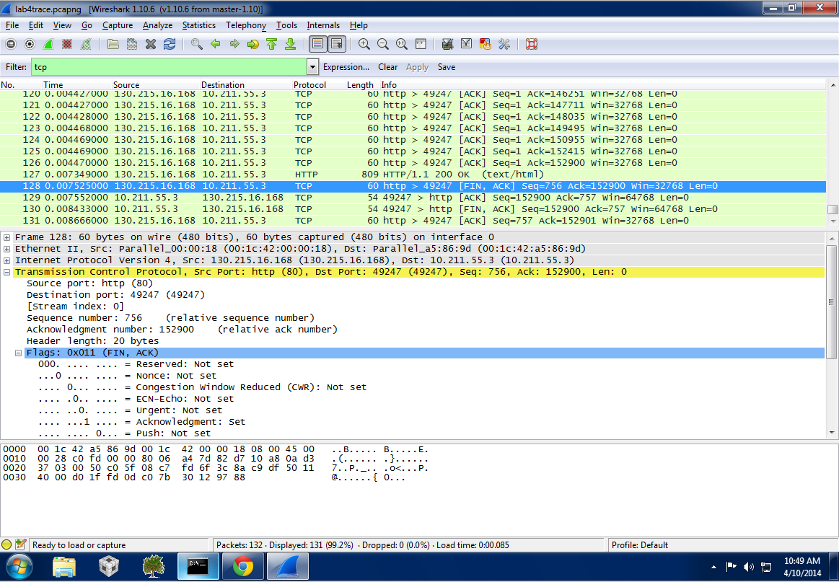

1.